**Introduction**

The electrodes are a critical component in the high voltage system for the n2EDM experiment. The optimization of the electrodes is essential for achieving the highest electric field within the precession chamber, increasing the sensitivity to the nEDM. In the previous nEDM experiment, we were able to achieve a potential on the high voltage electrode of $V_{HV}=200 kV$. This resulted in a maximum electric field of $\sim 32 \frac{kV}{cm}$. The results of the previous experiment can be used as a guideline to see which aspects of the design are most important for the maximum achievable electric field. Since evidence for breakdowns was seen on the window of the insulator ring, this is an important area of interest. It is also critical that the maximum electric field is kept relatively similar as it was demonstrated that a field of $\sim 32 \frac{kV}{cm}$ is achievable under experimental conditions. This corresponds to an electric field of $40 \frac{kV}{cm}$ in simulations where $V_{HV}=250 kV$.

There are several constraints on the geometry of the precession chamber. The inner diameter of the insulator ring is fixed at $800 mm$, the overall height of the insulator ring is limited to $150 mm$, the spacing between the HV electrode and ground electrodes is fixed at $120 mm$, and the overall width of the precession chamber and ground shell is limited to the size of the vacuum chamber $1700 mm$.

**Optimization Process**

The software used for the optimization process was COMSOL. COMSOL is a finite element analysis software that allows the user to build complex geometries and simulate how they will behave under various conditions. COMSOL is ideal for the optimization process as it allows the user to add in geometry parameters as a variable and simulate many different values in one run. By looking at how the electric field changes in high priority regions, the ideal electrode geometry can be determined.

There are two key components for the overall precession chamber design that need to be optimized, the electrodes and the ground shell. A list of the optimized parameters is given below:

* Electrodes
  + HV Electrode Bulb
  + HV Electrode Thickness
  + Ground Electrode Extension
  + HV Electrode Diameter
  + UCN Plug Radius
* Ground Shell
  + Ring Thickness
  + Number of Rings
  + Alternative Ring Placement
  + Alternative Ground Shell Designs
    - Phillip’s Design
    - Full Ground Shell

**Electrode Optimization**

The first aspect of the electrodes that needed to be decided was the shape of the HV Electrode. Initially, there were two main designs, a $50 mm$ thick electrode with a bulb shape on the end and a flat electrode with a variable thickness.

**Bulb Shape**

The bulb shape design attempts to keep the overall thickness of the precession chamber the same as previously specified while reducing the maximum electric field seen on the end of the HV electrode. An example of this design can be seen in figure 1. As table 1 shows, this design is effective at reducing the maximum electric field, however, it also increases the electric field within the window region of the insulator ring. One possible solution to this would be to move the window region closer to the ground electrode, however, this will provide an asymmetry in the system that could potentially reduce the maximum achievable voltage of the system. As such, the bulb shaped HV electrode is not a viable solution for the design.

Figure 1: HV electrode design with a bulb shaped end

|  |  |  |  |  |  |  |  |  |
| --- | --- | --- | --- | --- | --- | --- | --- | --- |
| Bulb Diameter (mm) | HV (kV/cm) | Inner GE (kV/cm) | Outer GE (kV/cm) | Inside HV Groove (kV/cm) | Outside HV Groove (kV/cm) | Flange (kV/cm) | Outside GE Groove (kV/cm) | Window (kV/cm) |
| 50 | 49.191 | 29.902 | 18.032 | 29.478 | 30.359 | 0.12847 | 26.714 | 19.501 |
| 60 | 45.974 | 29.9 | 18.516 | 29.174 | 29.33 | 0.13151 | 27.009 | 19.524 |
| 70 | 43.321 | 29.903 | 19.139 | 28.481 | 26.348 | 0.13497 | 27.522 | 19.691 |
| 80 | 41.559 | 29.902 | 19.854 | 26.975 | 20.614 | 0.13828 | 28.317 | 20.206 |

Table 1: Electric field measurements for the bulb shaped electrode optimization

**Variable Thickness**

The variable thickness electrode design reduces the electric field by increasing the thickness of the entire HV electrode. This allows for the end to have a larger radius of curvature while keeping the entire electrode flat. An example of this design can be seen in the baseline design shown in figure 2. As shown in table 2, this design decreases the electric field on the high voltage electrode without changing the electric fields in other high priority regions. The limit on the thickness of the HV electrode is a combination of the increased weight and overall height limitation of the precession chamber. For these reasons, the thickness of $60 mm$ was kept in the baseline design.

Figure 2: Thick HV Electrode design

|  |  |  |  |  |  |  |  |  |
| --- | --- | --- | --- | --- | --- | --- | --- | --- |
| hvT (mm) | HV (kV/cm) | Inner GE (kV/cm) | Outer GE (kV/cm) | Inside HV Groove (kV/cm) | Outside HV Groove (kV/cm) | Flange (kV/cm) | Outside GE Groove (kV/cm) | Window (kV/cm) |
| 50 | 49.19 | 29.901 | 18.032 | 29.455 | 30.369 | 0.12846 | 26.715 | 19.501 |
| 60 | 45.313 | 29.9 | 17.929 | 29.502 | 30.496 | 0.13603 | 26.661 | 19.505 |
| 70 | 42.28 | 29.901 | 17.791 | 29.56 | 30.663 | 0.14359 | 26.592 | 19.509 |

Table 2: Electric field measurements for the Thick HV Electrode design

**Ground Electrode Extension**

The next parameter is the relative diameter of the ground electrode compared to the HV electrode. By decreasing the diameter of the ground electrode, the maximum electric field decreases and the electric field outside of the precession chamber increases (less shielding). By increasing the diameter of the ground electrode, the maximum electric field increases and the electric field outside of the precession chamber decreases (more shielding). This can be seen in table 3. A ground electrode extension of $60 mm$ was chosen to have the required amount of shielding outside of the chamber.

|  |  |  |  |  |  |  |  |  |
| --- | --- | --- | --- | --- | --- | --- | --- | --- |
| geE (mm) | HV (kV/cm) | Inner GE (kV/cm) | Outer GE (kV/cm) | Inside HV Groove (kV/cm) | Outside HV Groove (kV/cm) | Flange (kV/cm) | Outside GE Groove (kV/cm) | Window (kV/cm) |
| -20 | 44.356 | 29.903 | 23.973 | 29.31 | 30.113 | 0.17203 | 27.311 | 19.377 |
| 0 | 44.628 | 29.902 | 22.49 | 29.39 | 30.245 | 0.16213 | 27.034 | 19.429 |
| 20 | 44.882 | 29.9 | 20.992 | 29.46 | 30.362 | 0.15285 | 26.855 | 19.464 |
| 40 | 45.111 | 29.9 | 19.462 | 29.496 | 30.433 | 0.14407 | 26.737 | 19.488 |
| 60 | 45.314 | 29.9 | 17.928 | 29.529 | 30.504 | 0.13618 | 26.662 | 19.505 |
| 80 | 45.488 | 29.901 | 17.267 | 29.548 | 30.534 | 0.12886 | 26.609 | 19.516 |

Table 3: Electric field measurements from the ground electrode diameter optimization

**HV Electrode Diameter**

Changing the diameter of the HV electrode has a significant impact on the electric field as it can increase or decrease the distance from the HV electrode to the ground shell. This change can be seen in table 4. A HV electrode diameter of $1000 mm$ was chosen because at this diameter, the edge effect of the HV electrode has a reduced impact on the electric field inside the insulator groove on the HV electrode.

|  |  |  |  |  |  |  |  |  |
| --- | --- | --- | --- | --- | --- | --- | --- | --- |
| D (mm) | HV (kV/cm) | Inner GE (kV/cm) | Outer GE (kV/cm) | Inside HV Groove (kV/cm) | Outside HV Groove (kV/cm) | Flange (kV/cm) | Outside GE Groove (kV/cm) | Window (kV/cm) |
| 960 | 44.608 | 29.901 | 18.587 | 30.209 | 32.745 | 0.12371 | 25.921 | 19.573 |
| 1000 | 45.314 | 29.9 | 17.928 | 29.529 | 30.504 | 0.13618 | 26.662 | 19.505 |
| 1040 | 46.296 | 29.901 | 18.056 | 29.148 | 29.554 | 0.15354 | 27.194 | 19.442 |

Table 4: Electric field measurements from the HV Electrode Diameter optimization

**UCN Plug Radius**

The radius on the UCN plug influences the electric field on the ground electrode inside the chamber. This can be seen in table 5. The electric field in this region can be brought in line with other electric fields in the system by having a UCN Plug radius of $20 mm$.

|  |  |  |  |  |  |  |
| --- | --- | --- | --- | --- | --- | --- |
| ucnR (mm) | HV (kV/cm) | Inner GE (kV/cm) | Outer GE (kV/cm) | Inside HV Groove (kV/cm) | Outer HV Groove (kV/cm) | Flange (kV/cm) |
| 10 | 45.354 | 30.808 | 25.547 | 29.527 | 30.534 | 0.12036 |
| 15 | 45.362 | 29.051 | 25.53 | 29.532 | 30.534 | 0.12004 |
| 20 | 45.358 | 27.909 | 25.531 | 29.539 | 30.537 | 0.1204 |
| 25 | 45.366 | 27.572 | 25.521 | 29.534 | 30.527 | 0.11982 |

Table 5: Electric field measurements from the UCN Plug Radius optimization

**Ground Shell Optimization**

There are several designs that could have been implemented for the ground shell, several grounded rings, a fully enclosed ground shell, and a hybrid of the two designs.

**Ground Shell Ring Thickness**

This parameter was optimized concurrently with the number of rings. The ring diameter of $20 mm$ was chosen as a balance of electric field on the HV electrode and shielding of the electric field on the flange of the vacuum chamber.

**Number of Rings**

As the electric field outside of the precession chamber was too high, several more rings needed to be added. In this case, the 9th and 10th rings were added above and below the previous set of rings. These rings provided the additional shielding of the electric field outside of the precession chamber that was necessary. The magnitude of the electric field in this region can be seen in figure 3. 10 rings were chosen as they provide enough shielding outside of the precession without significantly increasing the electric field on the high voltage electrode.

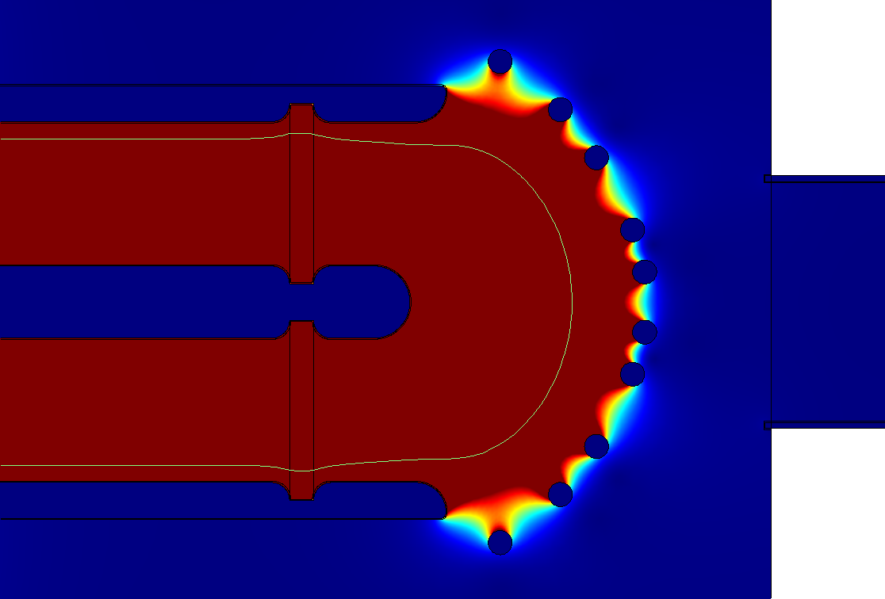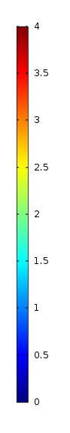

Figure 3: Ground shell design with 10 rings. Scale set to maximum of 4 kV/cm

**Alternative Ring Placement**

Several alternative locations for the placement of the rings were explored. Individual optimization of the ring locations resulted in an electric field reduction of $\sim 1\frac{kV}{cm}$ on the HV electrode, however, this reduced the shielding outside of the precession chamber significantly.

**Alternative Ground Shell Designs**

There were several proposed ground shell designs that needed to be investigated. An idea of having curved, longer ground electrodes and the idea of having a full ground shell made of thin aluminum.

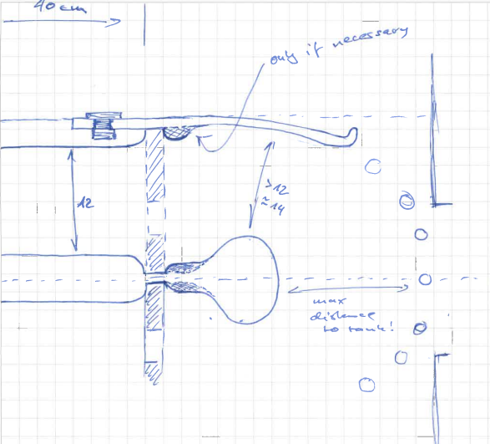

Figure 4: Concept design for the curved ground electrodes

In this idea, the ground electrodes are curved around a bulb shaped electrode as shown in figure 4. This design was implemented in COMSOL and is shown in figure 5. The results of the simulation can be seen in table 6. This design offers no benefit in terms of the electric field on the HV Electrode while also further complicating the manufacturing process, as such, it will not be used.

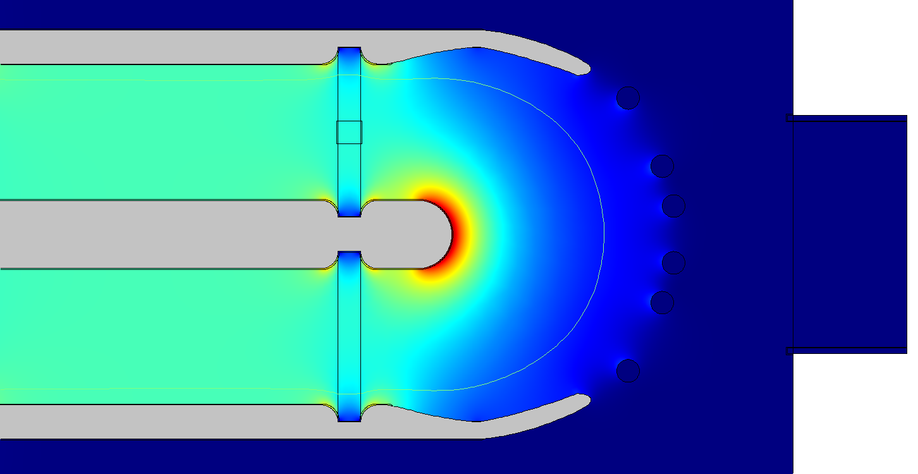

Figure 5: COMSOL simulation of the curved ground electrodes

The final alternative design was having a full ground shell as shown in figure 6. This idea was then simulated with the results displayed in table 6. While there is a slight reduction on the maximum electric field on the HV Electrode, this design is significantly more complicated to machine and support within the vacuum chamber. This design would also interfere with the vacuum pumping of the chamber.

Figure 6: Cylindrically symmetric full ground shell design. This was done as an estimation for the full ground shell design that is not cylindrically symmetric

|  |  |  |  |  |  |  |
| --- | --- | --- | --- | --- | --- | --- |
| HV (kV/cm) | Inner GE (kV/cm) | Outer GE (kV/cm) | Inside HV Groove (kV/cm) | Outer HV Groove (kV/cm) | Flange (kV/cm) | Window (kV/cm) |
| 45.115 | 27.937 | 25.819 | 29.522 | 30.489 | 0.092263 | 19.487 |

Table 6: Electric field values from the cylindrically symmetric ground shell simulation

**Results**

The result of this optimization process can be seen in figure 7. This electric field values for this design are in table 7. As shown, this design provides adequate shielding for the region outside of the precession chamber while keeping the electric field on the HV Electrode near the target electric field.

Figure 7: The final optimized geometry for the electrodes and ground shell

|  |  |  |  |  |  |  |  |  |
| --- | --- | --- | --- | --- | --- | --- | --- | --- |
|  | HV (kV/cm) | Inner GE (kV/cm) | Outer GE (kV/cm) | Inside HV Groove (kV/cm) | Outside HV Groove (kV/cm) | Flange (kV/cm) | Outside GE Groove (kV/cm) | Window (kV/cm) |
| Baseline | 45.313 | 29.9 | 17.929 | 29.502 | 30.496 | 0.13603 | 26.661 | 19.505 |
| Optimized | 45.424 | 29.9 | 17.984 | 29.537 | 30.515 | 0.1271 | 26.691 | 19.494 |

Table 7: Electric field measurements of the design before and after the optimization